**Experiment No: 1**

**Experiment Name: Experimenting The Behavior Of Layer 1 and Layer 2 Switches.**

**Theory:** I like to think of physical layer switches is as a ‘software-controlled patch panel’.  It is a bit smarter than that, but it’s a good starting point.  When you install your test device in your lab, you connect it’s ports to the physical layer switch.  From then on, you use the software controlling the physical layer switch to interconnect other test devices, as per your physical test topology.  The marketing speak for this is the “wire-once” approach and it does generally work that way. Once an internal connection is made within the physical layer switch, the now-paired routers ‘appear’ to be directly connected to each other.  The name  ‘physical layer or layer-1 switch comes from the fact that they’re trying ’emulate’ the behavior of a physical cable between the two devices.

A L2 switch does switching only. This means that it uses MAC addresses to switch the packets from a port to the destination port (and only the destination port). It therefore maintains a MAC address table so that it can remember which ports have which MAC address associated.

**Tools/Components:**

1 computer/Laptop.

2. layer 1 switch

3. layer 2 switch

4 cable,

5 Cisco packet tracer.

**Procedure:**

**Layer 1:**1 Takes 5 laptop and one 2960-24 switch and connecting laptop with switch by copper straight through.

2. Set up laptop and switch of following.

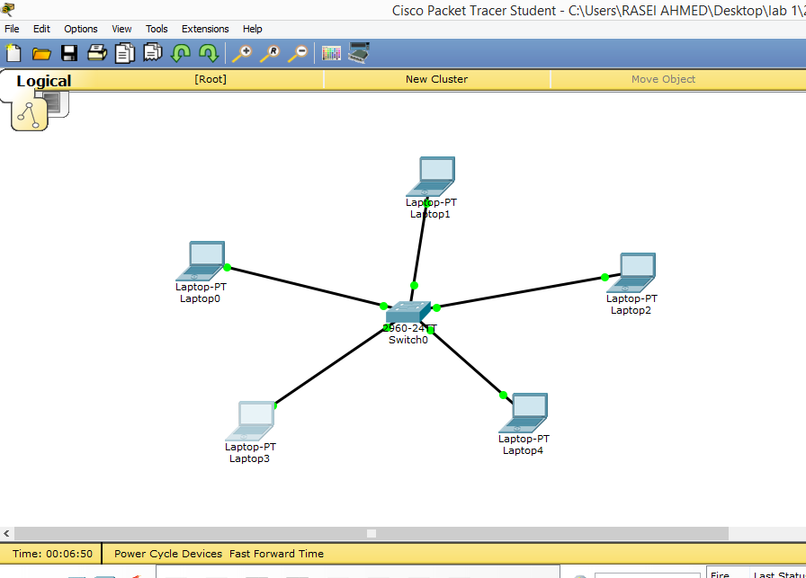

3. Configuration each laptop of following.

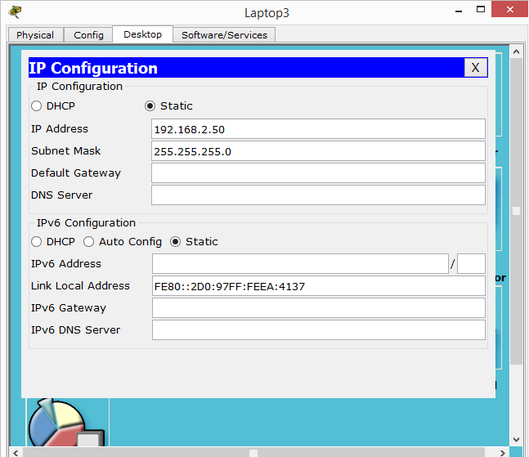

**Layer 2 switch:**

**Procedure:**

1 Takes 4 pc and switch and connecting them by copper straight through cable.

2. Take 4 pc and a hub and connecting them by copper straight through cable.

3. Switch and hub are connected by copper straight through cable.

4. set up pc and switch and hub of following:

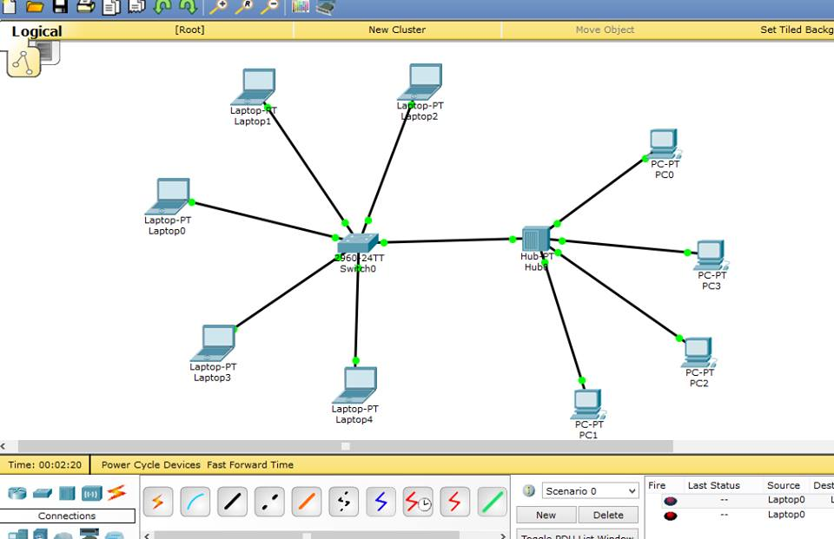

5. Configuration all pc of following:

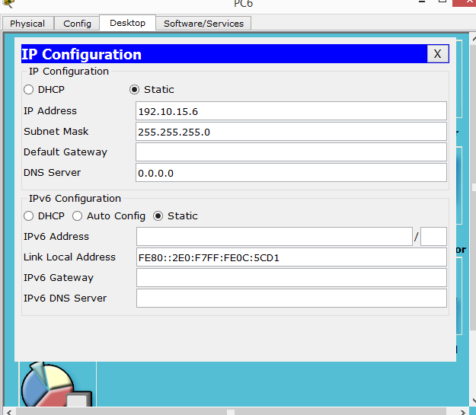

**Conclusion:** Machine A lookup’s for Machine D MAC address in its ARP table. If MAC Address found then packet is formed and sent to Switch If MAC address not found then ARP Request is generated and MAC address is obtained. Switch A receives packet and checks for MAC Address in its MAC Address Table. .If MAC Address matched it will forward packet on matched port number. .If MAC Address not found then the packet is broadcasted to all ports, except on which it has received the p